owl differences between 1 and 2 are not very important, we use owl 2

OWL 2 have many rules

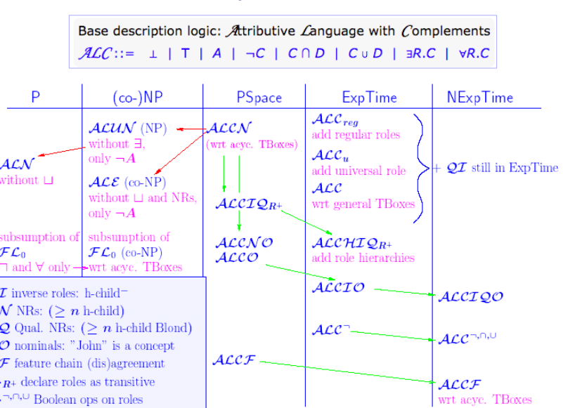

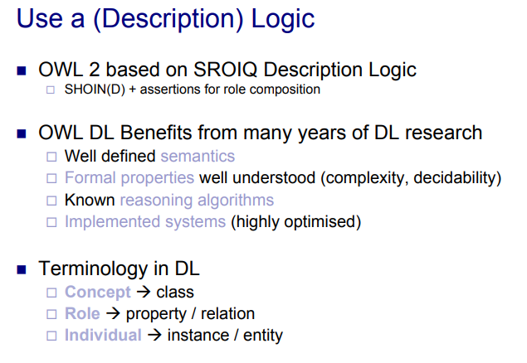

SROIQ